Hierarchical Clustering Results
Generated: 2026-05-27 19:53:51

Parameters
Index | Parameter | Value
0 | Number of Clusters | 2
1 | Linkage Method | ward
2 | Standardized | True
3 | Variables Used | Price, Quality, YoungAppeal, Luxury, Distribution, Innovation
4 | Observations | 24

Cluster Sizes
Index | Cluster | Count | Percentage
0 | 0 | 16 | 66.7%
1 | 1 | 8 | 33.3%

Fit Measures
Index | Metric | Value | Interpretation
0 | Silhouette Score | 0.4963580792480176 | Closer to 1 is better
1 | Davies-Bouldin Index | 0.7432601912530703 | Lower is better
2 | Calinski-Harabasz Score | 30.972348447944256 | Higher is better

Cluster Assignments
Index | Price | Quality | YoungAppeal | Luxury | Distribution | Innovation | Cluster
0 | 95 | 98 | 65 | 99 | 85 | 75 | 1
1 | 85 | 92 | 70 | 90 | 88 | 80 | 1
2 | 35 | 70 | 85 | 20 | 95 | 85 | 0
3 | 60 | 78 | 75 | 65 | 90 | 70 | 0
4 | 80 | 90 | 95 | 85 | 100 | 98 | 0
5 | 65 | 85 | 88 | 60 | 98 | 90 | 0
6 | 70 | 82 | 85 | 70 | 92 | 95 | 0
7 | 55 | 80 | 90 | 45 | 85 | 92 | 0
8 | 45 | 75 | 92 | 30 | 88 | 90 | 0
9 | 75 | 88 | 72 | 80 | 85 | 82 | 1
10 | 78 | 89 | 70 | 82 | 80 | 85 | 1
11 | 50 | 78 | 88 | 45 | 90 | 80 | 0
12 | 70 | 85 | 95 | 75 | 98 | 88 | 0
13 | 65 | 82 | 93 | 68 | 97 | 86 | 0
14 | 50 | 75 | 90 | 50 | 92 | 82 | 0
15 | 55 | 78 | 88 | 55 | 88 | 85 | 0
16 | 92 | 85 | 60 | 98 | 75 | 65 | 1
17 | 90 | 84 | 58 | 96 | 73 | 68 | 1
18 | 95 | 86 | 55 | 99 | 78 | 60 | 1
19 | 98 | 88 | 50 | 100 | 70 | 55 | 1
20 | 40 | 70 | 90 | 35 | 95 | 85 | 0
21 | 30 | 65 | 92 | 25 | 98 | 80 | 0
22 | 35 | 72 | 85 | 30 | 95 | 75 | 0
23 | 40 | 68 | 80 | 28 | 93 | 70 | 0

Visualizations
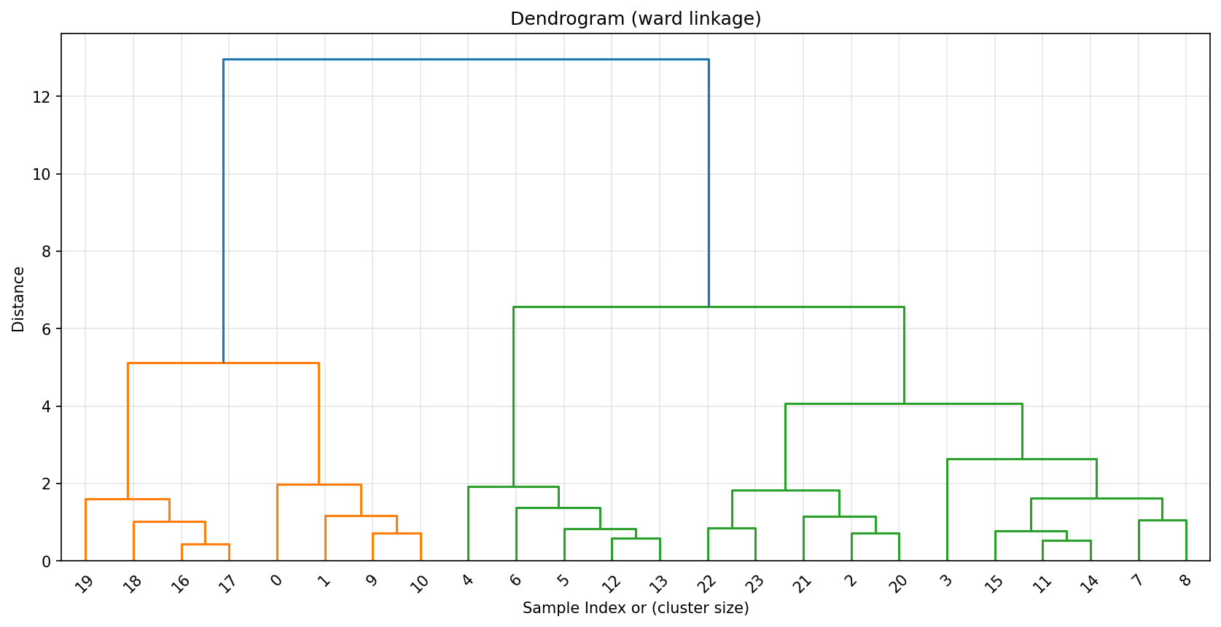
Figure 1

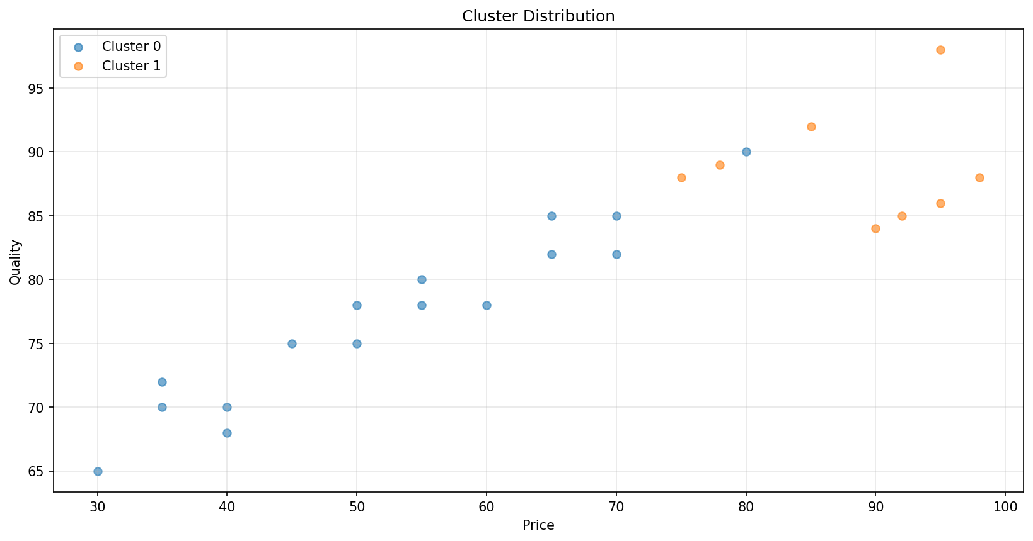
Figure 2

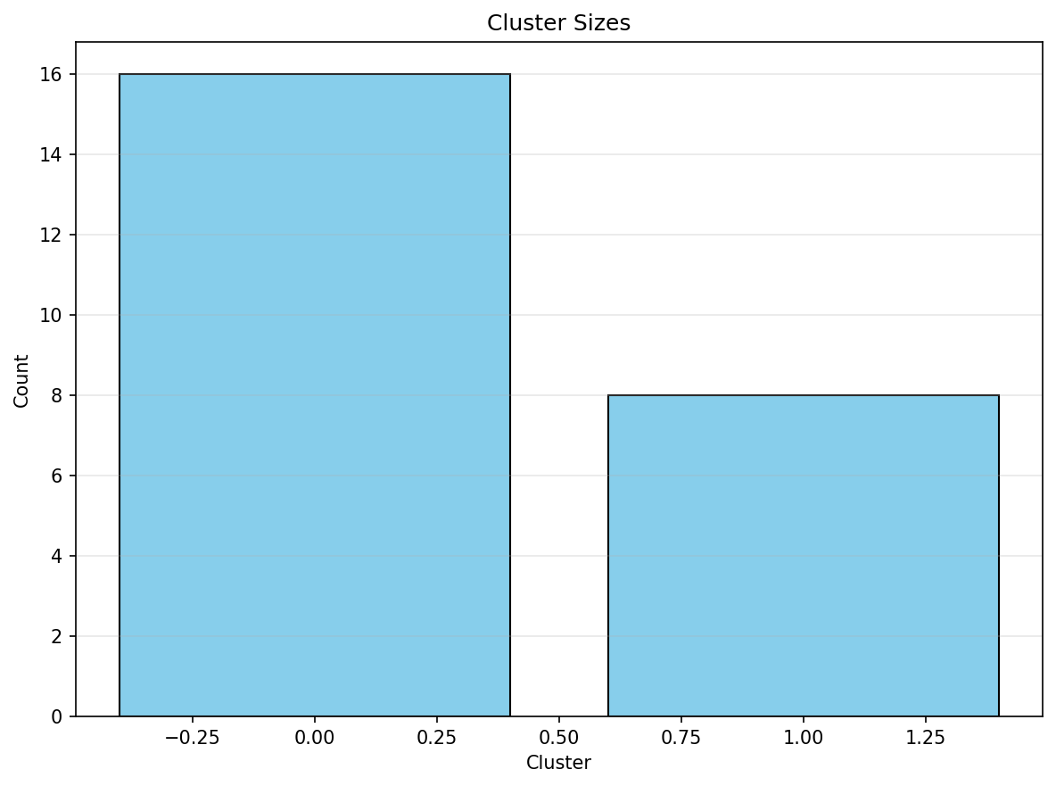
Figure 3

